Customer churn analysis

1522 words

Assignment 2: Empirical project in Python

Table of Contents
Executive Summary 5
Introduction: 5
Data Exploration 5
Dataset Overview: 5
Preprocessing: 6
Missing values: 6
Standardizing Values: 6
EDA: 7
Numerical: 7
Categorical: 8
Model Choice 9
Model development 9
Key metrics: 10
Model Evaluation 10
Feature & Insights: 11
Recommendations: 12
References: 14

Executive Summary
Telco, a subscription based, and telecommunications company is facing increasing customer churn which impacting profitability and efficiency across internal departments. This report uses Machine learning techniques like Catboost that have emerged as powerful tools compared to traditional Logistic regression for predicting and understanding customer churn. Model performance was evaluated with Recall, F1-score, and ROC-AUC metrics. Key churn drivers include customer contract type, internet service, and tenure. These findings provide actionable insights, enabling targeted ad strategies and product bundles to retain high-risk customers and enhance overall retention.

Introduction:
Many telecom and subscription companies struggle with customer churn, similar to how Telcom suffers, with about 26.26% of their customers (1,313 people) choosing to remove their services. Churn directly impacts a company’s revenue and ability to stay, since it costs much more to acquire new customers than to keep the ones you have (Ahmad et al. 2019; Park and Ahn 2022).
With machine learning, businesses can spot likely customers who might cancel their subscription and find out why with churn analysis. As a Data Analyst my job is to solve classification problem such as churn in Python to construct models that accurately predict and informs findings that helps Marketing department point out the most vulnerable segments and highlight what service factors cause people to leave for the Product department, guiding data-driven and creative answers that keep customers loyal and add value to the business value.

Data Exploration

Dataset Overview:
The Telco Customer Churn dataset (Blastchar 2018) is used with a 5000-row restriction and 21 columns of observations to inform potential variables that impact churn:
Type | Key columns | Why impact churn
Customer demographic | Age, gender, partner, etc | May influence service loyalty patterns for marketing tactics
Services used | Internet, phone, multiple lines, etc | Service usage trend informs satisfaction with Telcom’s products offerings
Account information | TotalCharges, MonthlyCharges, Contract, PaperlessBilling, etc | Financial feasibility can lead to decision to churn
Figure 1: Key columns. Based on data from BlastChar (2018)
TotalCharges was incorrectly stored as an object type rather than numeric causing it to have over 4000 unique values that would break the entire model pipeline if ignored.
Categorical inspection via .select_dtypes(include=['object']) and .nunique() further uncovered that features like OnlineBackup, StreamingTV, and TechSupport contained inconsistent categories such as "No internet service", which, without correction, could introduce noise and redundancy in the model

Preprocessing:
To address identified issues and prepare the dataset. The preprocessing steps include standardizing columns and handling missing values (Bilal et al. 2022).

Missing values:
At first missing(df) was used to confirm missing values which returned none. However, df[df['TotalCharges'] == ' '] was deployed due to suspicion of the large amount of unique values which revealed several columns with missing datas that would have been missed if we relied on missing(df) command and converted to NaN to avoid complexing preprocessing step since gradient-boosting models interally process them effectively already (Bentéjac et al. 2021).

Standardizing Values:
CustomerID column is dropped as it provides no meaningful churn predictors. For the service-related variables, "No internet service" responses were replaced with "No" based on the assumption that both responses mean no usage of said services.
Categorical features required encoding for trend visualization and binary variables like gender were encoded using simple label encoding (converting 'Yes'/'No' to 1/0), while multi-category variables such as Contract underwent one-hot encoding to prevent ordinal relationships. TotalCharges were converted from object type to float to enable numerical processing.

EDA:
The dataset is imbalanced with 26% churn, thus informing the model’s key metric to avoid accuracy and prevent a model that’s only good at predicting the majority class (Ho et al. 2020). This fact also requires EDA as a vital step in uncovering key trends and anomalies, which guide the choice of statistical tests and modeling techniques (Bilal et al. 2022), especially feature importance. This analysis will be divided into numerical and categorical sections to evaluate the key drivers of churn.

Numerical:
Overall, there’s a weak correlation between the numerical features and churn. However, it reveals Monthlycharges and Tenure to be statistically significant (Figure 2)
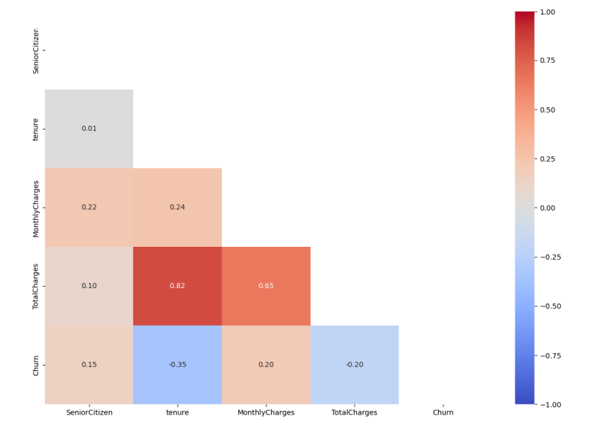
Figure 2: Numerical Feature heatmap to churn
While the imbalanced dataset has 26% churn overall, MonthlyCharges shows them costing the company around 30% revenue loss. Theoretically, higher-paying customers show increased churn rates following MonthlyCharges’s pattern, possibly indicating that price sensitivity (Moser et al. 2018) or higher expectations aren’t met with product purchases.
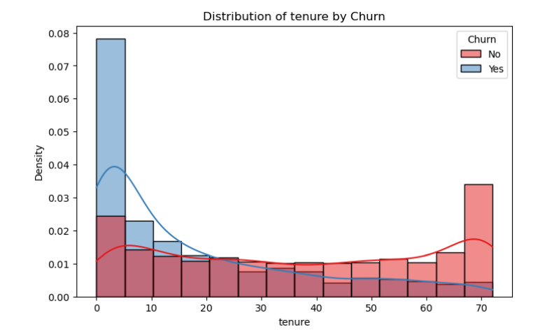
Figure 3: Distribution of tenure by churn
Tenure’s negative relationship with churn proves that customers who stayed longer with the company are less likely to leave. This informs us that customers have a certain amount of time within their contract before becoming loyal.

Categorical:
Overall churn rate peaks at three services, with 100% of customers with 2+ services to have Internet as the anchor product; thus, if they drop it, customers are likely to churn.
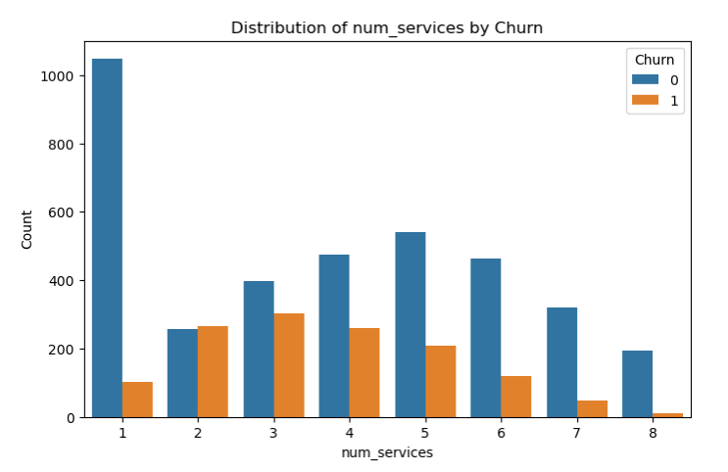
Figure 4: Number of services to churn
Theoretically, contract type and payment method both influence churn through their impact on commitment and convenience to product experience (Nitzan and Ein-Gar 2019).
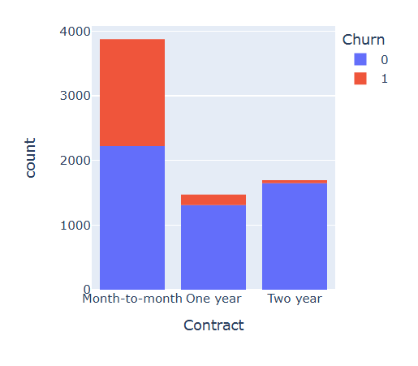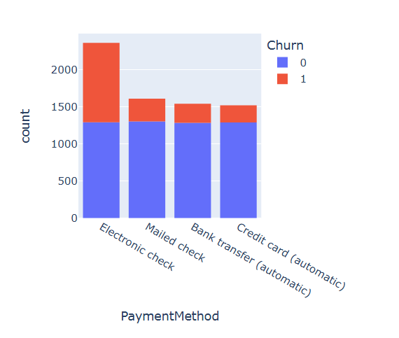
Figure 5: Churn trend of Contract type and payment method
Customers on flexible month-to-month plans face less switching cost, thus are more likely to churn alongside ease of product purchase (Ribeiro et al. 2024). Figure 5 further supports this: churn rates are 42.28% for month-to-month customers, compared to only 2.34% for two-year contracts. Moreover, users paying via electronic check show a 45.72% churn rate, while automatic options like credit cards are 14.23%. These patterns suggest contract length and frictionless billing are the main drivers of reducing churn.

Model Choice

Model development
Telco Customer Churn is a classification problem that requires models to capture complex, non-linear customer behavior patterns with dominant categorical features while effectively handling mixed data types and class imbalance. Gradient boosting algorithms excel in these requirements by sequentially correcting prediction errors and automatically identifying feature interactions (Guo and Chang 2022) therefore, Catboost and LightGBM were picked for their enhanced ability to process categorical variables without extensive preprocessing time (Bentéjac et al. 2021)
Dataset was split into a 70:30 train-test split with fixed random_state for reproducibility. Five-fold cross-validation was implemented during development to address potential sampling bias and ensure reliable performance estimates.

Key metrics:
For an imbalanced set, accuracy metrics can be misleading for churn prediction as models with high accuracy only excel at predicting the majority class (Wu et al. 2021) while failing to identify any churners. Therefore, this analysis prioritized recall, F1-score (for precision, accuracy trade off), and ROC-AUC (measuring discriminative ability across thresholds).
Hyperparameter optimization was conducted via grid search to enhance model performance for small dataset of 5000 rows:
CatBoost Parameters (Hassanali et al. 2024)
learning_rate | Controls step size for each iteration (smaller values require more trees but can improve accuracy
depth | Maximum tree depth for balancing model complexity
l2_leaf_reg | L2 regularization to prevent overfitting
scale_pos_weight = 5 | Addressing class imbalance by weighting positive examples more heavily
LightGBM parameters (Li et al. 2024)
num_leaves | Controls complexity of tree structure
max_depth | Limits tree depth to prevent overfitting
reg_lambda | L2 regularization
class_weight = 5 | to handle class imbalance

Figure 6: Hyperparameters for models

Model Evaluation
While both models performed well, CatBoost got higher churn identification capability with higher recall (0.9 vs. 0.7), roughly the same F1-score and lower ROC than LightGBM (0.75 vs 0.83) but still within industry benchmark (Mattson et al. 2020).
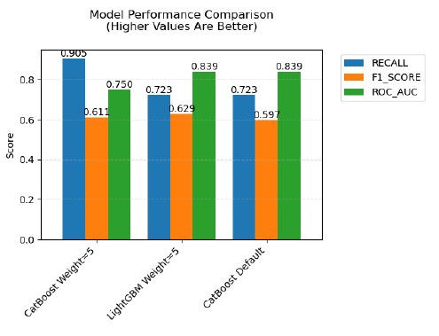
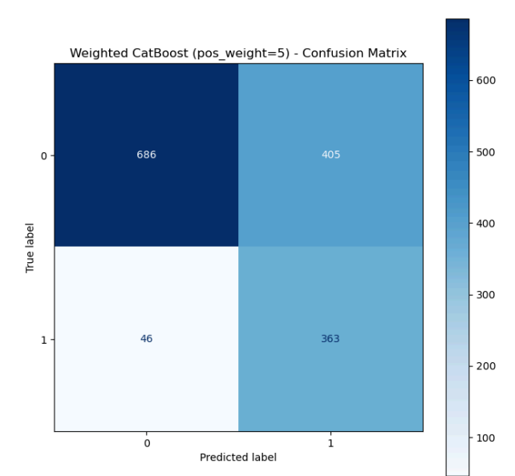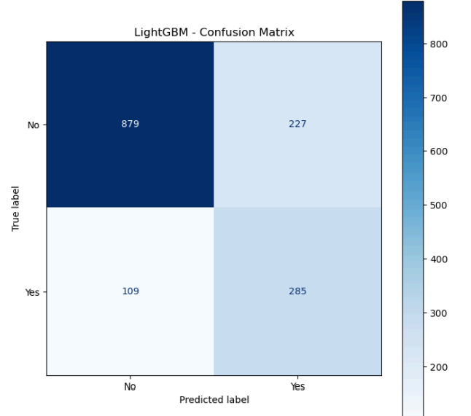
Figure 7
This means that CatBoost correctly identified more actual churners than LightGBM, achieving the primary business objective of identifying customers requiring intervention, though at the cost of a 5% higher false positive rate. Given that missed churners represent the most costly error type from a business perspective, CatBoost's superior recall justified its selection as the preferred model.

Feature & Insights:
SHAP values were used to quantify each variable's impact while accounting for feature interactions while interpreting the CatBoost model and determining the top 5 features to churn predictions (Chehreh Chelgani et al. 2024).
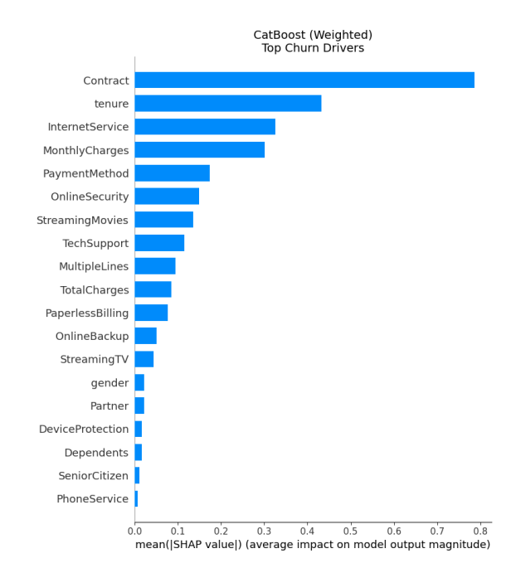
Figure 8: CAtBoost SHAP feature importance
From figure 8 and connect with EDA findings, Month-to-month contracts demonstrated the strongest positive association with churn, indicating customers without long-term commitments are most vulnerable. Fiber optic internet service emerged as the second most influential factor (41% churn from EDA code) alongside MonthlyCharges, as pointed out to represent price sensitivity. Telcom's product problem lies mainly in fiber optic pricing, suggesting potential service quality issues that require investigation or a need for product bundle to be more attractive. Tenure further supports that early customer retention tactics lead to long-lasting, loyal customers.
Marketing department's retention efforts should prioritize month-to-month customers, particularly those with fiber service and shorter tenure. Product department needs to look further into product bundles as customers with 3+ services are less likely to churn, especially when they have TechSupport as pointed out from EDA code.

Recommendations:
The most effective strategy for preventing customer churn is building product quality offerings (Borah et al. 2020). The marketing department should deploy personalized retention campaigns utilizing the model's ability to identify specific high-risk IDs (Figure 9). A targeted Facebook ads strategy can achieve this as its core offering. Telcom can compile IDs of all customers with data collection of their Facebook social and push Telcom's ads to their Facebook feed (Meta 2019). The main result is offering contract upgrades with graduated discounts, incentivizing longer-term commitments while preserving monthly revenues.
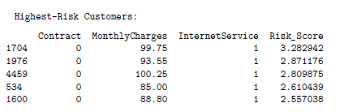
Figure 9
The main problem with the fiber-optic product is its price segmentation. Telcom can also use the high-risk ID list to identify high-churn geographic clusters and concentrate its offering on the appropriate market segment. Secondly, to improve the products, customer pain points such as price sensitivity should be solved by Bundle deals (Online Security, Tech Support, and Device Protection) with core offerings (Jena and Ghadge 2022), while addressing the customer pain point, such as dissatisfaction in customer service, to point out further insights on why Fiber Optic has high churn.

References:
Ahmad AK, Jafar A and Aljoumaa K (2019) 'Customer churn prediction in telecom using machine learning in big data platform', Journal of big data, 6(1):1-24, doi:10.1186/s40537-019-0191-6.
Bentéjac C, Csörgő A and Martínez-Muñoz G (2021) 'A comparative analysis of gradient boosting algorithms', The Artificial intelligence review, 54(3):1937-1967, doi:10.1007/s10462-020-09896-5.
Bilal M, Ali G, Iqbal MW, Anwar M, Malik MSA and Kadir RA (2022) 'Auto-Prep: Efficient and Automated Data Preprocessing Pipeline', IEEE access, 10:107764-107784, doi:10.1109/ACCESS.2022.3198662.
Blastchar (2018) Telco Customer Churn, Kaggle website, accessed 15 May 2025. https://www.kaggle.com/datasets/blastchar/telco-customer-churn/data
Borah SB, Prakhya S and Sharma A (2020) 'Leveraging service recovery strategies to reduce customer churn in an emerging market', Journal of the Academy of Marketing Science, 48(5):848-868, doi:10.1007/s11747-019-00634-0.
Chehreh Chelgani S, Homafar A, Nasiri H and Rezaei laksar M (2024) 'CatBoost-SHAP for modeling industrial operational flotation variables – A “conscious lab” approach', Minerals engineering, 213:108754, doi:10.1016/j.mineng.2024.108754.
Guo C-Y and Chang K-H (2022) 'A Novel Algorithm to Estimate the Significance Level of a Feature Interaction Using the Extreme Gradient Boosting Machine', International journal of environmental research and public health, 19(4):2338, doi:10.3390/ijerph19042338.
Hassanali M, Soltanaghaei M, Javdani Gandomani T and Zamani Boroujeni F (2024) 'Software development effort estimation using boosting algorithms and automatic tuning of hyperparameters with Optuna', Journal of software : evolution and process, 36(9):n/a, doi:10.1002/smr.2665.
Ho SY, Wong L and Goh WWB (2020) 'Avoid Oversimplifications in Machine Learning: Going beyond the Class-Prediction Accuracy', Patterns (New York, N.Y.), 1(2):100025-100025, doi:10.1016/j.patter.2020.100025.
Jena SK and Ghadge A (2022) 'Product bundling and advertising strategy for a duopoly supply chain: a power-balance perspective', Annals of operations research, 315(2):1729-1753, doi:10.1007/s10479-020-03861-9.
Li S, Jin N, Dogani A, Yang Y, Zhang M and Gu X (2024) 'Enhancing LightGBM for Industrial Fault Warning: An Innovative Hybrid Algorithm', Processes, 12(1):221, doi:10.3390/pr12010221.
Mattson P, Reddi VJ, Cheng C, Coleman C, Diamos G, Kanter D, Micikevicius P, Patterson D, Schmuelling G, Tang H, Wei G-Y and Wu C-J (2020) 'MLPerf: An Industry Standard Benchmark Suite for Machine Learning Performance', IEEE MICRO, 40(2):8-16, doi:10.1109/MM.2020.2974843.
Meta (2019) Audience ad targeting, Facebook website, accessed 19 May 2025. https://www.facebook.com/business/ads/ad-targeting
Moser S, Schumann JH, von Wangenheim F, Uhrich F and Frank F (2018) 'The Effect of a Service Provider’s Competitive Market Position on Churn Among Flat-Rate Customers', Journal of service research : JSR, 21(3):319-335, doi:10.1177/1094670517752458.
Nitzan I and Ein-Gar D (2019) 'The "Commitment Projection" Effect: When Multiple Payments for a Product Affect Defection from a Service', Journal of marketing research, 56(5):842-861, doi:10.1177/0022243719850504.
Park W and Ahn H (2022) 'Not All Churn Customers Are the Same: Investigating the Effect of Customer Churn Heterogeneity on Customer Value in the Financial Sector', Sustainability, 14(19):12328, doi:10.3390/su141912328.
Ribeiro H, Barbosa B, Moreira AC and Rodrigues RG (2024) 'Determinants of churn in telecommunication services: a systematic literature review', Management review quarterly, 74(3):1327-1364, doi:10.1007/s11301-023-00335-7.
Wu S, Yau W-C, Ong T-S and Chong S-C (2021) 'Integrated Churn Prediction and Customer Segmentation Framework for Telco Business', IEEE access, 9:62118-62136, doi:10.1109/ACCESS.2021.3073776.

